# AppCross Common Library Specification

Version 0.0.1

內容

AppCross Common Library Specification 1

Version 0.0.1 1

1. 概述 3

2. Common Class 3

2.1 Catalog 3

2.2 Build Common Library 5

3. Common Library Description 8

3.1 Bitmap Handler 8

3.2 Clear Cache 9

3.3 XML Parser 9

3.4 Device 10

3.5 Event Handler 10

3.6 Event Message 10

3.7 File Handler 12

3.8 Sqlite Handler 13

3.9 Thread Handler 14

3.10 Data Type 14

3.11 Version Handler 15

3.12 Word Handler 15

3.13 Zip Handler 15

## 概述

AppCross Common Library 主要提供Android AppCross Reader程式共用的函數與物件，在設計上會將每個功能設計成獨立的模組，共用元件包含了Zip、Device、Bitmap、File、Event….等行為的功能。

## Common Class

### Catalog

|  |  |  |
| --- | --- | --- |
| **Module Name** | **File** | **Description** |
| Bitmap Handler | BitmapHandler.java | Handle bitmap resize、read bitmap、rotate、combine、cut |
| Clear Cache | ClearCache.java | Clear android process cache file |
| XML Parser | XmlParser.java  SaxParserHandler.java  ConfigData.java | Parse XML format file |
| Device | Device.java | Get scale size、device size、android version、display size。 |
| Event Handler | EventHandler.java | Send message to handler |
| Event Message | EventMessage.java | Define message to send |
| File Handler | FileHandler.java | Read file、find file |
| Intent Handler | IntentHandler.java | Handle Intent result |
| Debug Log | Logs.java | Show debug log |
| Image button handler | ObjectFactory.java | Handle Image button |
| Share | Share.java | Call android share intent |
| Sqlite Handler | SqliteHandler.java | Handle SQLite DB object |
| Thread Handler | ThreadHandler.java | Create and Handle thread |
| Data type | Type.java | Define data type |
| Version Handler | VersionHandler.java | Get android version name |
| Word Handler | WordHandler.java | Get string from android string.xml |
| Zip Handler | Zip.java | Express zip file |

### Build Common Library

所有Common Library放在同一個Android Project，Project name是Common，目錄結構：

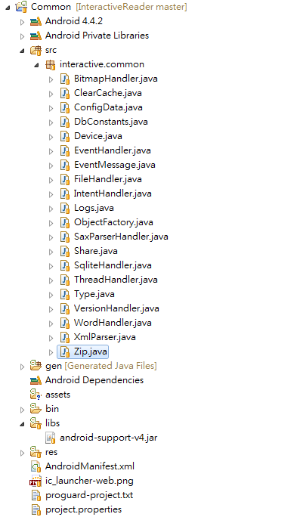

在Build Common Library時，記得要先確定Project properties內的”Is Library”要被選取

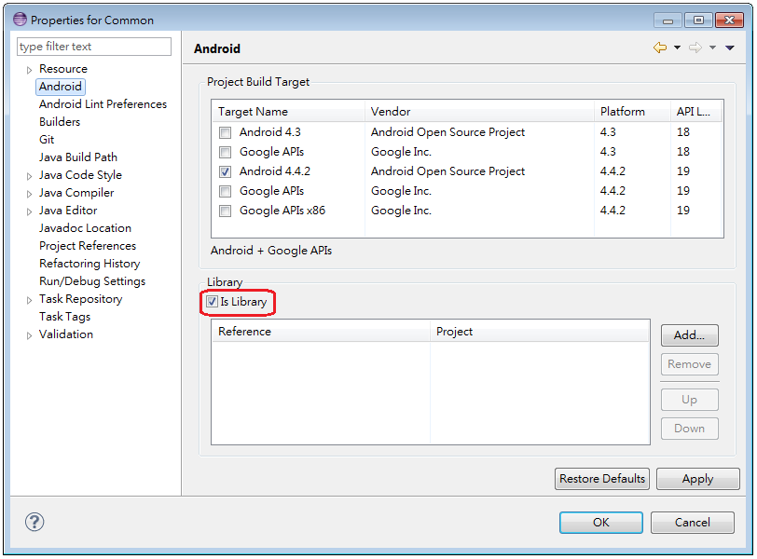

直接執行Eclipse的Clean and Build

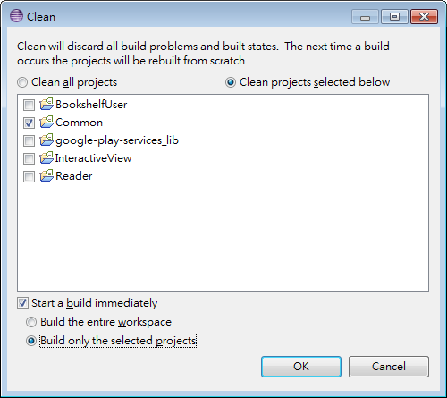

Build complete後，會在bin資料夾產生common.jar即完成。

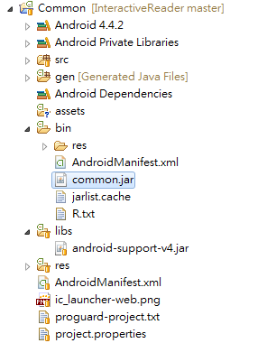

## Common Library Description

### Bitmap Handler

* 主要處理程式UI圖檔跟動態Load書籍圖檔，由於Android的cache size不大，所以Bitmap Handler在load bitmap時會採用FileInputStream去讀取bitmap檔減少使用到Android的cache。
* Bitmap Handler在讀取圖檔時亦會偵測圖檔size，如果圖檔size大於4096*4096則會自動縮小圖檔size為4096*4096。
* Bitmap Handler提供combine bitmap跟cut bitmap函數，主要處理互動元件的scrollable功能。
* loadBitmapFromView函數則是抓取Device 上view的畫面，將畫面存成bitmap。

|  |  |
| --- | --- |
| Function name | Description |
| int getMaxTexDim() | 讀取Android最大支援的解圖Size |
| Bitmap readBitmap(Context context, int resId) | 從resouce id讀取圖檔 |
| Bitmap readBitmap(Context context, String strFilePath, int reqWidth, int reqHeight, boolean bResize) | 從圖檔路徑讀取圖檔，將圖檔依據指定的size輸出bitmap物件，會先清除cache file |
| Bitmap readBitmap(String strFilePath, int reqWidth, int reqHeight, boolean bResize) | 從圖檔路徑讀取圖檔，將圖檔依據指定的size輸出bitmap物件，不會先清除cache file |
| int calculateInSampleSize(BitmapFactory.Options options, int reqWidth, int reqHeight) | 計算圖檔resize時需要的scale size |
| Bitmap getResizedBitmap(Bitmap bm, int newWidth, int newHeight) | Resize bitmap |
| Bitmap combineBitmap(Bitmap background, Bitmap foreground, float left, float top) | 兩張圖檔合併 |
| Bitmap getScreenshotsForCurrentWindow(Activity activity) | 快照畫面用bitmap物件輸出 |
| Bitmap cutBitmap(Bitmap mBitmap, Rect r, Bitmap.Config config) | 切割圖檔 |
| int getBitmapWidth(String strFilePath) | 取得圖檔寬度 |
| int getBitmapHeight(String strFilePath) | 取得圖檔高度 |
| Bitmap loadBitmapFromView(Context context, View v) | 將View物件畫面輸出成bitmap物件 |
| void releaseBitmap(Bitmap bitmap) | Recycle bitmap object |

### Clear Cache

清理AppCross Reader程式執行時產生的cache files。

|  |  |
| --- | --- |
| Function name | Description |
| void clearApplicationData(Context context) | 清除程式暫存檔與cache file |
| void trimCache(Context context) | 清除程式cache |

### XML Parser

讀取書籍的definition.xml將資料存到configData資料結構內，XML Parser採用SAX object去parse XML檔。

|  |  |
| --- | --- |
| Function name | Description |
| void parse(File file, ConfigData configData) | Parse XML file將資料存到ConfigData資料結構 |

### Device

抓取Device display size，scale size、Android SDK Version。

|  |  |
| --- | --- |
| Function name | Description |
| int getDisplayWidth() | 取得螢幕寬長的解析度 |
| int getDisplayHeight() | 取得螢幕高長的解析度 |
| int getDeviceWidth() | 取得螢幕實際寬度 |
| int getDeviceHeight() | 取得螢幕實際高度 |
| float getScaleSize() | 根據解析度與實際寬高計算scale size |
| int getOrientation() | 取的Device目前的直橫狀態 |
| boolean isLargeDisplaySize() | 判斷螢幕是否為大size螢幕 |
| double getDisplayIncheSize() | 取得螢幕inch size |
| int getDeviceType() | 判斷螢幕是phone或是table |
| boolean checkInstallation(String packageName) | 判断是否安装指定的應用程式 |
| void installApp(Activity activity, String strAppPackageName) | 引導跳轉去Google Play上某個應用的詳細頁面 |
| int getAndroidSdkVersion() | 取得Android SDK version |
| String getAndroidReleaseVersion() | 取得Android API version |

### Event Handler

透過notify函數傳送Message給特定的Handler。

|  |  |
| --- | --- |
| Function name | Description |
| void notify(Handler handler, int nWhat, int nEvent, int nPosition, Object object) | 傳送Message到指定的Handler |

### Event Message

定義程式所有的Message ID，從1024開始累加。

**public** **static** **final** **int** *MSG_CUSTOM* = 1024;

**public** **static** **final** **int** *MSG_CHAPTER* = *MSG_CUSTOM* + 1;

**public** **static** **final** **int** *MSG_PAGE* = *MSG_CUSTOM* + 2;

**public** **static** **final** **int** *MSG_VIEW_INITED* = *MSG_CUSTOM* + 3;

**public** **static** **final** **int** *MSG_WEB* = *MSG_CUSTOM* + 4;

**public** **static** **final** **int** *MSG_JUMP* = *MSG_CUSTOM* + 5;

**public** **static** **final** **int** *MSG_VIEW_CHANGE* = *MSG_CUSTOM* + 6;

**public** **static** **final** **int** *MSG_MEDIA_PLAY* = *MSG_CUSTOM* + 7;

**public** **static** **final** **int** *MSG_MEDIA_PAUSE* = *MSG_CUSTOM* + 8;

**public** **static** **final** **int** *MSG_MEDIA_STOP* = *MSG_CUSTOM* + 9;

**public** **static** **final** **int** *MSG_SHOW_PROGRESS* = *MSG_CUSTOM* + 10;

**public** **static** **final** **int** *MSG_FLIPPER_CLOSE* = *MSG_CUSTOM* + 11;

**public** **static** **final** **int** *MSG_NOTIFY_ROTATE* = *MSG_CUSTOM* + 12;

**public** **static** **final** **int** *MSG_IMAGE_CLICK* = *MSG_CUSTOM* + 13;

**public** **static** **final** **int** *MSG_SHOW_ITEM* = *MSG_CUSTOM* + 14;

**public** **static** **final** **int** *MSG_DOUBLE_CLICK* = *MSG_CUSTOM* + 15;

**public** **static** **final** **int** *MSG_START_UNEXPRESS* = *MSG_CUSTOM* + 16;

**public** **static** **final** **int** *MSG_CHECKED_BOOK* = *MSG_CUSTOM* + 17;

**public** **static** **final** **int** *MSG_GO_FORWARD* = *MSG_CUSTOM* + 18;

**public** **static** **final** **int** *MSG_OPTION_ITEM_SELECTED* = *MSG_CUSTOM* + 19;

**public** **static** **final** **int** *MSG_LOCK_PAGE* = *MSG_CUSTOM* + 20;

**public** **static** **final** **int** *MSG_UNLOCK_PAGE* = *MSG_CUSTOM* + 21;

**public** **static** **final** **int** *MSG_LOCK_HORIZON* = *MSG_CUSTOM* + 22;

**public** **static** **final** **int** *MSG_UNLOCK_HORIZON* = *MSG_CUSTOM* + 23;

**public** **static** **final** **int** *MSG_LOCK_VERTICAL* = *MSG_CUSTOM* + 24;

**public** **static** **final** **int** *MSG_UNLOCK_VERTICAL* = *MSG_CUSTOM* + 25;

**public** **static** **final** **int** *MSG_ACTIVITY_RESULT* = *MSG_CUSTOM* + 26;

**public** **static** **final** **int** *MSG_ANIMATION_END* = *MSG_CUSTOM* + 27;

**public** **static** **final** **int** *MSG_DRAG_END* = *MSG_CUSTOM* + 28;

**public** **static** **final** **int** *MSG_CURRENT_ACTIVE* = *MSG_CUSTOM* + 29;

**public** **static** **final** **int** *MSG_BROWSER_CLOSE* = *MSG_CUSTOM* + 30;

**public** **static** **final** **int** *MSG_DRAG_START* = *MSG_CUSTOM* + 31;

**public** **static** **final** **int** *MSG_SEND_POSTCARD* = *MSG_CUSTOM* + 32;

**public** **static** **final** **int** *MSG_NOT_CURRENT_ACTIVE* = *MSG_CUSTOM* + 33;

**public** **static** **final** **int** *MSG_BUTTON_EVENT* = *MSG_CUSTOM* + 34;

**public** **static** **final** **int** *MSG_RESET* = *MSG_CUSTOM* + 35;

**public** **static** **final** **int** *MSG_ANIMATION_ZOOM* = *MSG_CUSTOM* + 36;

**public** **static** **final** **int** *MSG_ANIMATION_MOVE* = *MSG_CUSTOM* + 37;

**public** **static** **final** **int** *MSG_JUMP_FADE* = *MSG_CUSTOM* + 38;

**public** **static** **final** **int** *MSG_GCM_REGISTERED* = *MSG_CUSTOM* + 39;

**public** **static** **final** **int** *MSG_LOGIN* = *MSG_CUSTOM* + 40;

**public** **static** **final** **int** *KEY_BACK* = 4;

### File Handler

讀取指定的檔案，搜尋檔案，主要用在AppCross Reader尋找書籍檔時用到。

|  |  |
| --- | --- |
| Function name | Description |
| boolean unExpressFile(final String strSrcPath, final String strDistPath) | 解壓縮檔案，會呼叫zip模組去解壓縮 |
| void createPath(final String strPath) | 建立檔案路徑 |
| String getStringFromFile(String filePath) | 讀取檔案內容 |
| String convertStreamToString(InputStream is) | 將stream輸出成String物件 |
| boolean checkAssetFile(Activity activity, String strFile) | 檢查assets資料夾是否有指定的檔案存在 |
| void copyFileFromAssets(Activity activity, String file, String dest) | 將assets內指定的檔案複製到指定的資料夾路徑 |
| int getBookInfo(Activity activity, SparseArray<String> saResInfo) | 讀取assets內resource檔的內容 |
| String searchBookFile(String strBookFolder, String strFindFile) | 到指定的路徑搜尋指定的檔案 |
| String getSdcardPath() | 取得系統SD card路徑 |
| String searchFilePath(String path, String find) | 取得指定檔案的路徑 |
| String getObbFile(String strPath, String strPackName) | 搜尋OBB內是否有指定的檔案 |
| boolean fileRename(String strOldPath, String strOldFile, String strNewPath, String strNewFile) | 更改檔案路徑與檔名 |
| boolean fileCopy(String strOldPath, String strOldFile, String strNewPath, String strNewFile) | 複製檔案到指定的資料夾 |
| boolean deleteFile(String strFile) | 刪除檔案 |
| boolean delete(String strFile) | 刪除檔案與路徑 |
| StringBuffer getFileContent(String path) | 讀取檔案內容 |
| boolean isFileExist(String strFilePath) | 判斷檔案是否存在 |
| boolean checkPath(String strPath, boolean bCreate) | 判斷路徑是否存在 |

Intent Handler

主要用在Device照相功能，與Device Camera Intent溝通。

|  |  |
| --- | --- |
| Function name | Description |
| Bitmap activityResult(Activity activity, int requestCode, int resultCode, Intent data) | Android Camera intent call back，  Activity 的onResult會被呼叫，呼叫此函數抓取照片 |

Debug Log

統一的除錯諮詢，程式透過ShowTrace顯示除錯訊息。

|  |  |
| --- | --- |
| Function name | Description |
| void showTrace(String msg) | 顯示Log於Android Logcat view |
| void complain(Context context, String message) | 顯示Android Alert Dialog |

Image Button Handler

處理Image Button三種狀態的變化(Down,Up,Normal)。

|  |  |
| --- | --- |
| Function name | Description |
| ImageView getImageButton(int nId) | 從resource id取得image view物件 |
| int addImageButton(int nId, int nNormalId, int nTouchDownId, int nTouchUpId) | 新增image view行為圖檔id |
| void setImgBtnTouchDown(int nId) | 設定image view touch down時的圖檔 |
| void setImgBtnTouchUp(int nId) | 設定image view touch up時的圖檔 |
| void setImgBtnNormal(int nId) | 設定image view touch normal時的圖檔 |

Share

Android 分享Intent，會啟動Android share dialog。

|  |  |
| --- | --- |
| Function name | Description |
| void shareAll(String strTitle, String strSubject, String strMessage, SparseArray<String> listImagePath) | 呼叫Android share intent |

### Sqlite Handler

Create SQLite DB新增Table新增預設的資料，提供讀取與寫入的介面。

|  |  |
| --- | --- |
| Function name | Description |
| void onCreate(SQLiteDatabase db) | Call back function 如果DB不存在則create DB |
| void onUpgrade(SQLiteDatabase db, int oldVersion, int newVersion) | Call back function版本更新時被呼叫 oldVersion=舊的資料庫版本；newVersion=新的資料庫版本 |
| void onOpen(SQLiteDatabase db) | Call back function每次成功打開數據庫後首先被執行 |
| void close() | 關閉資料庫 |
| void addFavorite(int nChapter, int nPage) | 加入reader我的最愛資料到資料庫 |
| void deleteFavorite(int nChapter, int nPage) | 從資料庫刪除我的最愛資料 |
| void updateFavorite(int nOldChapter, int nOldPage, int nNewChapter, int nNewPage) | 更新資料庫我的最愛資料 |
| void getFavoriteData(SparseArray<FavoriteData> listData) | 取得我的最愛資料 |

### Thread Handler

Create Thread 設定thread屬性與執行。

|  |  |
| --- | --- |
| Function name | Description |
| void setThdId(int nThdId) | 設定thread id |
| void start() | 開始執行thread |
| void setName(String name) | 設定thread名稱 |
| void join() | Thread join |
| void setPriority(int androidOsPriority) | 設定thread屬性 |

### Data Type

定義基本資料型態。

**public** **static** **final** **int** *TRUE* = 1;

**public** **static** **final** **int** *FALSE* = 0;

**public** **static** **final** **int** *INVALID* = -1;

**public** **static** **final** **int** *VALID* = *TRUE*;

**public** **static** **final** **int** *TRACE_LEVEL_SIMPLE* = 1;

**public** **static** **final** **int** *TRACE_LEVEL_NORMAL* = *TRACE_LEVEL_SIMPLE* + 1;

**public** **static** **final** **int** *TRACE_LEVEL_DETAIL* = *TRACE_LEVEL_NORMAL* + 1;

**public** **static** **final** **int** *SMALLEST_SCREEN_WIDTH_DP* = 600;

**public** **static** **final** **int** *DEVICE_PHONE* = 0;

**public** **static** **final** **int** *DEVICE_TABLET* = 1;

**public** **static** **final** String *DEFAULT_STORAGE* = "/sdcard/download/";

### Version Handler

抓取Android SDK Version code和Version name。

|  |  |
| --- | --- |
| Function name | Description |
| int getVersionCode(Context context) | 取得Android SDK Version code |
| String getVersionName(Context context) | 取得Android API Version name |

### Word Handler

抓取Android文字定義檔string.xml內的定義文字。

|  |  |
| --- | --- |
| Function name | Description |
| String getString(Context context, String strName) | 取得android string.xml描述字 |

### Zip Handler

Zip檔解壓縮模組。

|  |  |
| --- | --- |
| Function name | Description |
| void zip(String[] files, String zipFile) | 壓縮檔案 |
| boolean unzip(String zipFile, String location) | 解壓縮檔案 |